Lab 4

GridBagLayout

Use the GridBaglayout manager to build the following screen layout. No event handling is required.

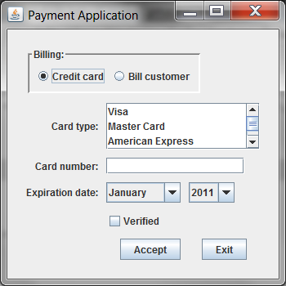

**Notes:**

The radio buttons are in a panel

The credit cards are in a JList – some of the sample code is provided below:

String[] cardNames = {"Visa", "Master Card", "American Express", "Other"};

cardTypeList = new JList(cardNames);

cardTypeList.setFixedCellWidth(170);

cardTypeList.setSelectionMode(ListSelectionModel.SINGLE_SELECTION);

cardTypeList.setVisibleRowCount(3);

JScrollPane cardTypeScrollPane = new JScrollPane(cardTypeList);